CNS 1410 Object-oriented Programming

Programming Project 9: Stack of Integers - Adding Exceptions and the Bridge Pattern

Due Date:
Must be submitted no later than 1:00am on Monday.
Programs received prior to 1:00am on Sunday will receive 5 bonus points, if the program completely meets the specifications and executes correctly.

Objective:
To give student's experience constructing a program that
- must manage dynamically allocated memory,
- uses exceptions correctly, and
- uses the Handle/Body or Bridge Design Pattern.

Project Description
This project has two major parts.
- Part One:
In this project, you will start with the class developed for project #8 that represents a Stack of integers. That Stack class has a couple of problems that can be nicely dealt with using exceptions.
  - If the stack is empty, we should not allow the pop( ) function to do anything. Popping an element off of an empty stack would create a potentially disastrous error condition.
  - If the stack is empty, we should not allow the top( ) function to do anything, for similar reasons.
Implement these exceptions by
  - Creating an EmptyStackException class. The class should contain a text message indicating that the stack is empty, and a what( ) function that returns the message.
  - Using the Stack class designed in the previous exercise, change the top( ) and pop( ) functions so that they throw an exception when the user tries to use either of them on an empty stack.
  - Add code to your driver that puts calls to top( ) and pop( ) in a try block. In the corresponding catch blocks, print out a message that the stack is empty.
- Part Two:
Another thing that we would like to do is hide the implementation of the Stack class by using the Handle/Body or Bridge design pattern. This design pattern is a well known technique for hiding implementation details. To do this, your stack class should contains a pointer to an Implementation class. All of the actual implementation details, as well as the private data members of the Stack class are defined in the Implementation class. The Handle/Body pattern is discussed in lab eight.

Your Program
Write a Program that implements the Stack class you designed. The implementation of the Stack class must be properly hidden using the bridge design pattern (10 points). In addition, your Stack class should throw an exception whenever the top( ) or pop( ) functions are invoked when the stack is empty (10 points).
Your driver should:
- Call cin.exceptions( ) so that cin throws exceptions when invalid data is entered (5 points)
- Create a loop that (15 points)
  - Prompts the user to enter an integer
  - Gets the user's input. If the stream throws an exception, reset the error bits, erase the keyboard buffer up to the next newline character, notify the user that the input was invalid, and try again
  - Pushes the integer value just input onto the stack
  - Increments a counter to keep track of the number of integers entered
  - Repeats until the user enters a value of zero.
- Creates a second loop that (10 points)
  - Prints the top element of the stack, using a try block to handle an empty stack
  - Removes the top element of the stack, using a try block to handle an empty stack
- Try to pop a final element off of the stack. Put this code in a try bock (10 points)
Format and document your code in accordance with the course style guidelines. Include a file prologue identifying you as the author. Submit your project using the instructions outlined in the Course Syllabus, Programming Projects section.

File(s) to Submit:
All source code files and an executable file.

Grading
The Grade sheet is here

Sample Output:
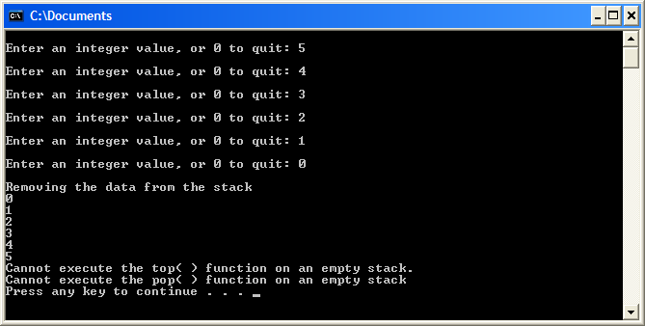

Sample Executable
A sample executable is here.

